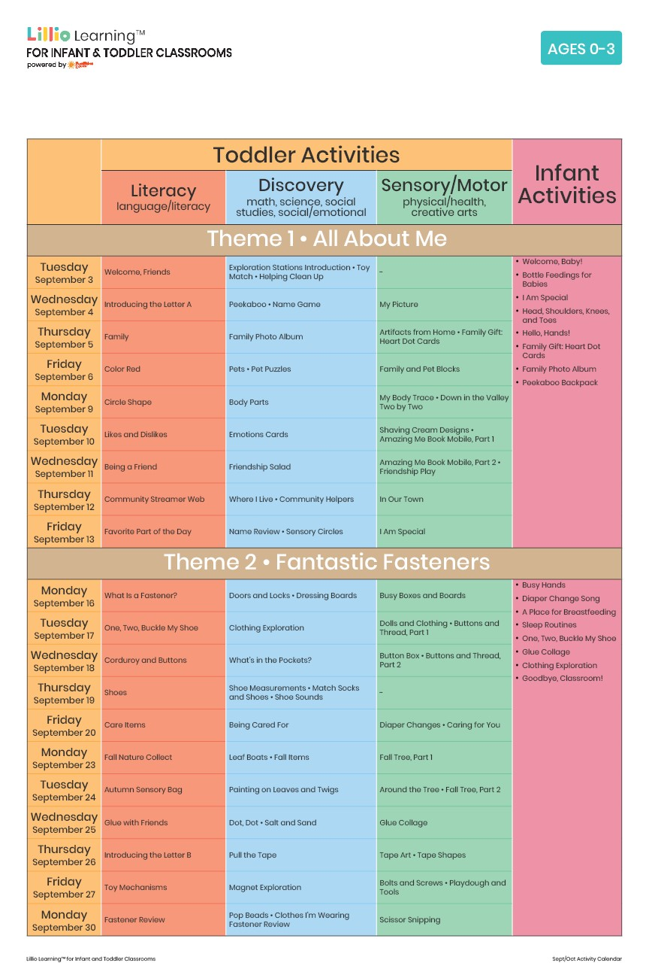

September 2024

Add Your Name/Logo Here

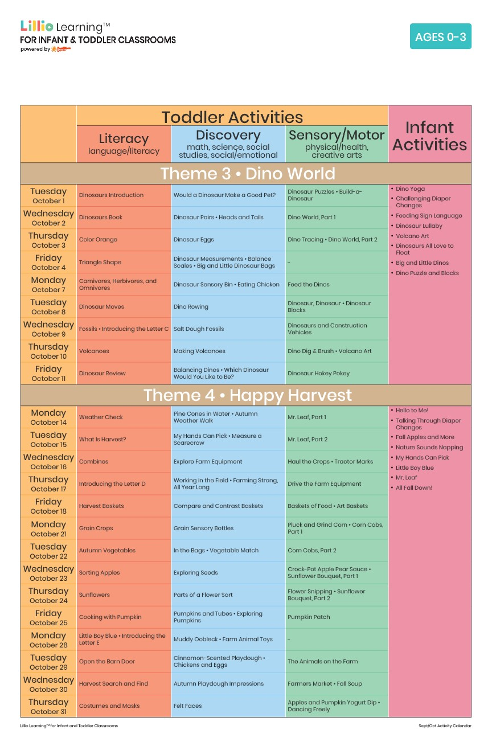

Add Your Name/Logo Here

October 2024